Experiment no : 01
Experiment Name : Basic use of matlab.
Problem 1 :
Write a program where 2 number given as input from keyboard and you need to show the sum, subtraction , multiplication and division of the two numbers.

Problem analysis :
- Input 2 numbers from the keyboard.
- Add 2 numbers
- Subtraction of 2 numbers
- Multiplication of 2 numbers
- Division of 2 numbers
- Display the results

Coding :

clc
clear
%% Taking Input
num1 = input('Enter Number 1: ');
num2 = input('Enter Number 2: ');
%% For Addition
fprintf('Sum is : %f\n', num1 + num2);
%% For Subtraction
fprintf('Subtraction is : %f\n', num1 - num2);
%% Multiplication
fprintf('Multiplication is : %f\n', num1 * num2);
%% Divition
fprintf('Divition is : %f\n', num1 / num2);

Output :

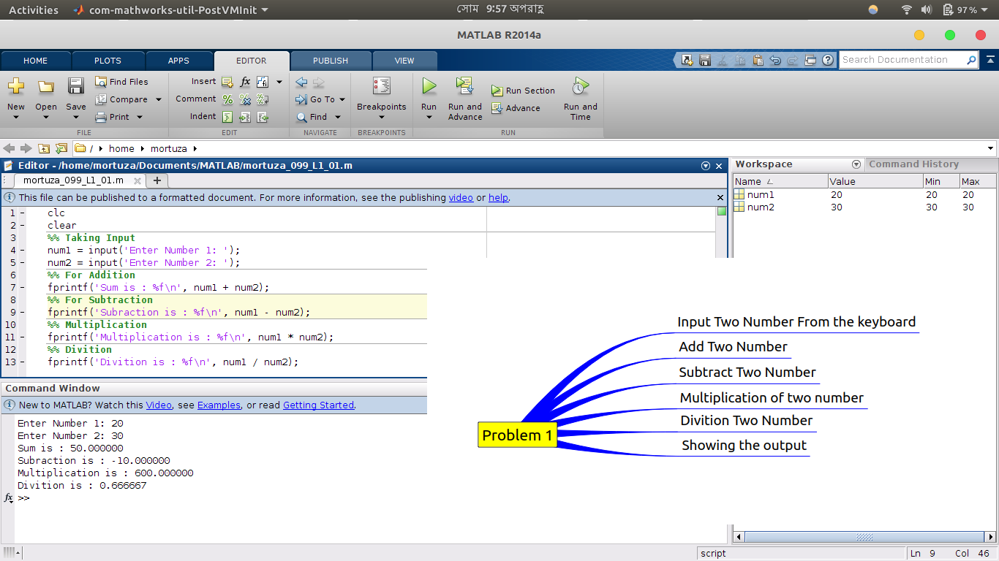

Problem 2 :
Write a program where 3 numbers will be given as input and you have to add first two numbers and then you have to determine the reminder of the result of the addition divided by the third number.

Problem analysis :

- Input 3 number from the keyboard
- Add first 2 numbers
- Reminder of addition and the 3rd number
- Showing the result

Coding :

clc
clear
%% Taking Input
num1 = input('Enter Number 1: ');
num2 = input('Enter Number 2: ');
num3 = input('Enter Number 3: ');
%{
1. Adding First two Number
2. Finding the reminder of the produced sum divided by number 3
%}
%% Ans Part
fprintf('The Result is : %f\n',mod((num1+num2),num3));

Output :

